GateWiz

Due date: 19 Jan, 2024

Due time: 11:59PM

**Digital Alarm Clock (For Group 3)**



Create a Verilog design for a clock with an alarm, incorporating the following features.

* Clock Generation
* Initializing clock time to a particular value
* Setting time for alarm
* Enabling and disabling alarm
* Stopping alarm

Presented here is the Block Diagram for the clock system

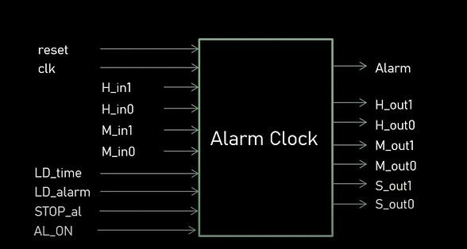



Here is the Flow chart illustrating the operations of the clock system

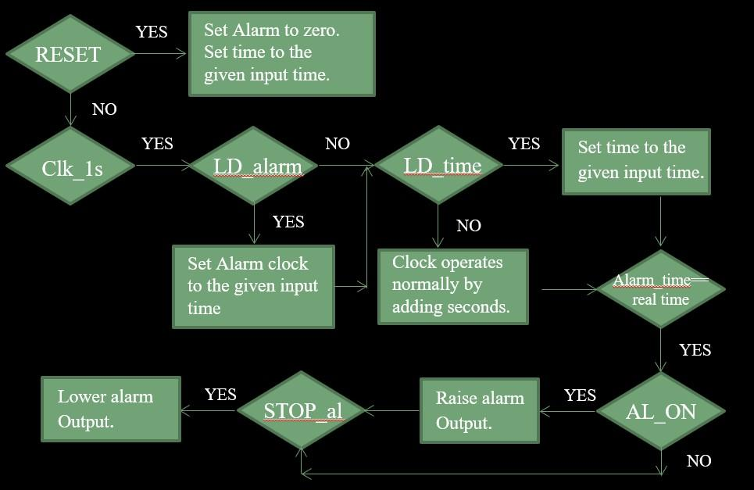



* Digital Alarm Clock

Inputs:

1. reset:

- Role: Reset Signal

- Function: Resets the clock to its initial state.

2. clk:

- Role: Clock Signal

- Function: Provides timing for the system, driving state transitions.

3. H_in1:

- Role: Hour Tens Digit Input

- Function: The tens digit for the hour input (range 0-2).

4. H_in0:

- Role: Hour Ones Digit Input

- Function: The ones digit for the hour input (range 0-9).

5. M_in1:

- Role: Minute Tens Digit Input

- Function: The tens digit for the minute input (range 0-5).

6. M_in0:

- Role: Minute Ones Digit Input

- Function: The ones digit for the minute input (range 0-9).

7. LD_time:

- Role: Load Time Signal

- Function: If asserted, the time values are loaded into the clock from the inputs `H_in1`, `H_in0`, `M_in1`, `M_in0`.

8. LD_alarm:

- Role: Load Alarm Signal

- Function: If asserted, the alarm values are loaded into the alarm register from `H_in1`, `H_in0`, `M_in1`, `M_in0`.

9. STOP_al:

- Role: Stop Alarm Signal

- Function: If asserted, it stops the alarm signal.

10. AL_ON:

- Role: Alarm On Signal

- Function: If asserted, the alarm will be activated if the current time matches the alarm time.

Outputs:

1. Alarm:

- Role: Alarm Output

- Function: Activates the alarm when the current time matches the set alarm time.

2. H_out1:

- Role: Hour Tens Digit Output

- Function: The tens digit for the hour (range 0-2).

3. H_out0:

- Role: Hour Ones Digit Output

- Function: The ones digit for the hour (range 0-9).

4. M_out1:

- Role: Minute Tens Digit Output

- Function: The tens digit for the minute (range 0-5).

5. M_out0:

- Role: Minute Ones Digit Output

- Function: The ones digit for the minute (range 0-9).

6. S_out1:

- Role: Second Tens Digit Output

- Function: The tens digit for the second (range 0-5).

7. S_out0:

- Role: Second Ones Digit Output

- Function: The ones digit for the second (range 0-9).